Research Review



# Research Questions:

1. Is there any relationship between the components of office environment and the performance level of employees?
2. Which component of office environment? Behavioral or physical has the greater impact on productivity of the employees.
3. Which elements of the two components of the office environment have the significant effect on the performance level of employees?

The **dependent variable** and **independent variables** of the study are as follows:

**Dependent Variable**

* Productivity of the Employees

**Independent Variables**

* **Physical Components** of Environment
* Comfort Level: Ventilation, heating, natural lighting, artificial lighting, decor, cleanliness, overall comfort, physical security.
* Office Layout: Informal meeting areas, formal meeting areas, quiet areas, privacy, personal storage, general storage, work area – desk and circulation space
* **Behavioral Components** of Environment
* Level of Interaction and Distraction: Social interaction, work interaction, creative physical environment, overall atmosphere, position relative to colleagues, position relative to equipment, overall office layout and refreshments.

Thus, this research study explores the following research **hypothesis.**

**H0:** There is no relationship between office environment and productivity of the employees

**H1**: There is a relationship between office environment and productivity of employees.

**H2**: It is the behavioral components of office environment that have a greater effect on productivity, than the physical components.

**H3**: It is the comfort level has the significant impact on the performance level of employees than office layout.

# 2. Main points:

1. Research **on Impact of Workplace Quality on Employees’ Productivity.**
2. Case Study of **Bank in Turkey**
3. The **workplace environment plays a crucial role for the employees.** Nowadays employees may have a large number working alternatives, then the environment in workplace becomes a critical factor for accepting and/or keeping the jobs.
4. The quality of environment in workplace may simply **determine the level of employee’s motivation, subsequent performance and productivity.**
5. Brill (1992) estimates that improvements in the physical design of the workplace may result in a **5-10 percent increase in employee productivity.**

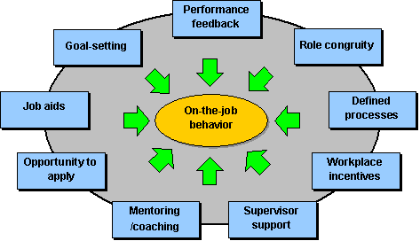

# 3. Physical Components:

1. Many organizations have been trying new designs and techniques to construct office buildings, which can increase productivity, and attract more employees. Many authors have noted that, the physical layout of the workspace, along with efficient management processes, is playing a major role in boosting employees’ productivity and improving organizational performance
2. According to the research, which included workplace designs, work satisfaction, and productivity:
   1. 89 percent of the respondents rated design, from important to very important.
   2. 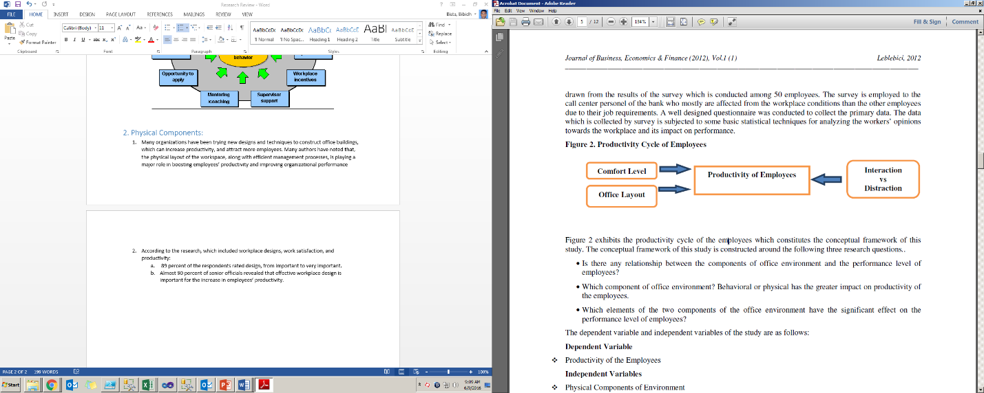Almost 90 percent of senior officials revealed that effective workplace design is important for the increase in employees’ productivity.